How to configure tomcat server in Eclipse ? (One time Requirement)

If you are using **Eclipse IDE first time**, you need to configure the tomcat server First.

For configuring the tomcat server in eclipse IDE, **click on servers tab at the bottom side of the IDE -> right click on blank area -> New -> Servers -> choose tomcat then its version -> next -> click on Browse button -> select the apache tomcat root folder previous to bin -> next -> addAll -> Finish.**

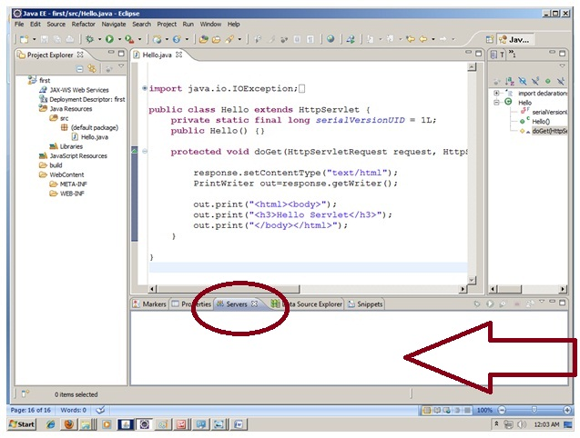

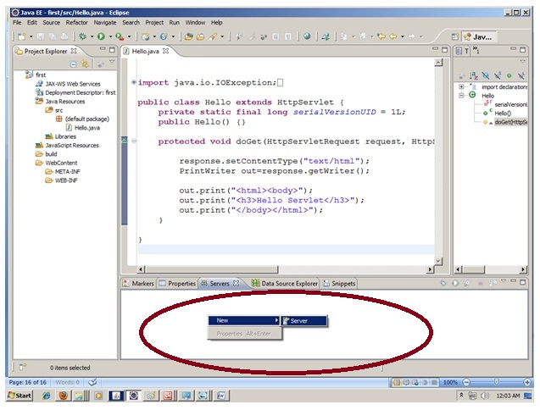

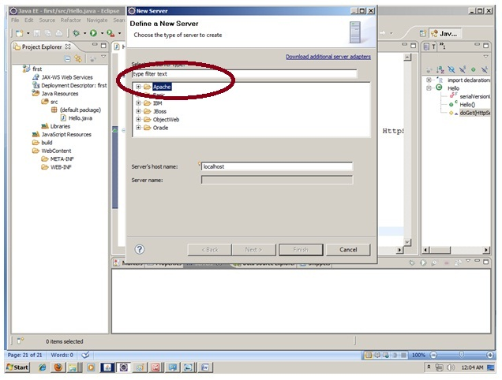

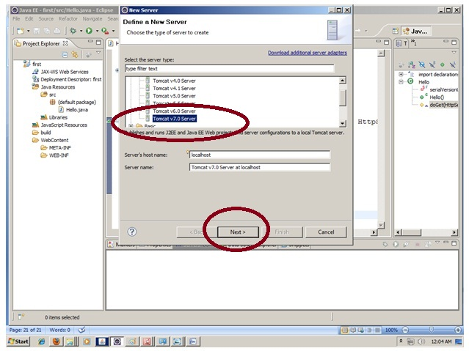

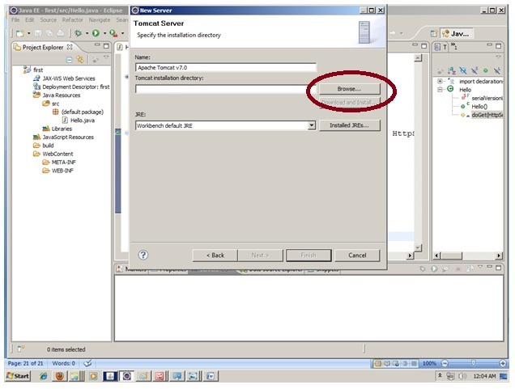

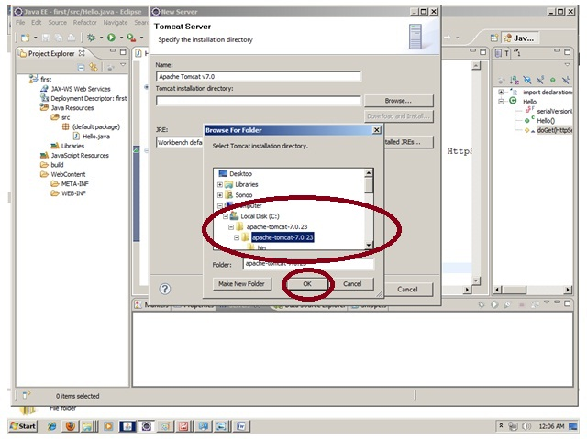

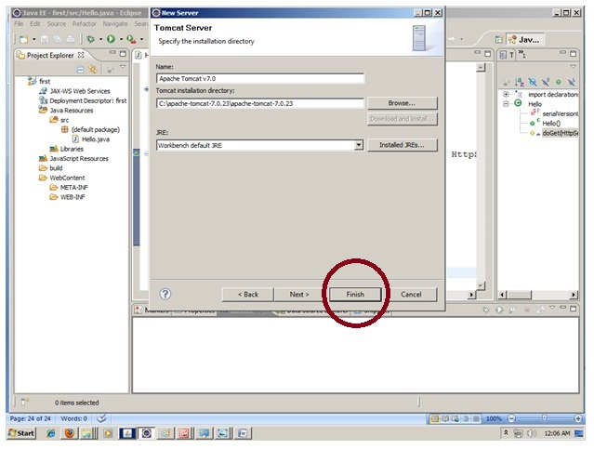

|  |
| --- |
| Now tomcat7 server has been configured in eclipse IDE. |

